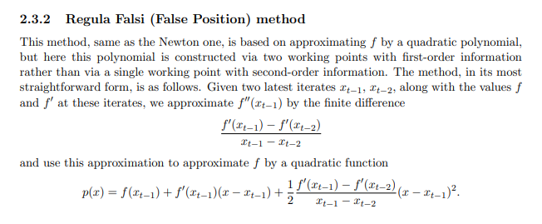

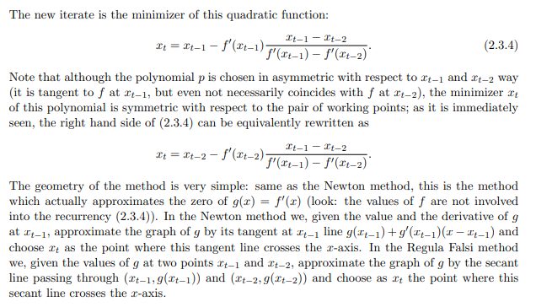

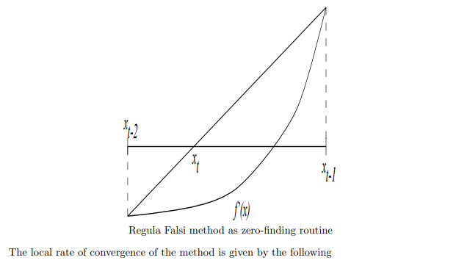

**[References](https://www2.isye.gatech.edu/~nemirovs/Lect_OptII.pdf)**

<https://www2.isye.gatech.edu/~nemirovs/Lect_OptII.pdf>